# **Unsupervised learning to find anomalies Presentation: Prof. Greg Landsberg, Prof. Loukas Gouskos Workshop: Prof. Greg Landsberg, Prof. Loukas Gouskos**

# **Overview of the Physics**

The Large Hadron Collider (LHC) at CERN (near Geneva Switzerland) is a cutting-edge energy frontier facility with the major goal of finding physics beyond the standard description of our universe, known as Standard Model. While many dedicated searches for new physics have come empty-handed so far, there are strong theoretical reasons to believe that the Standard Model is incomplete, despite its enormous success. At the same time, signatures for new physics may be different from the proposed theoretical paradigm and appear as subtle modifications of the properties of various objects in proton-proton collision events. In particular, jets--- the product of fragmentation of quarks and gluons, particles most copiously produced at the LHC---may carry these subtle signatures of new physics in their internal structure [1]. Given the lack of precise knowledge of how these modifications may look, a search for such anomalous signatures is a perfect problem for the rather novel concept in artificial intelligence: the unsupervised machine learning. In this approach, the discriminator based on deep neural networks and autoencoders, is trained on a large sample of ordinary jets expected from the Standard Model processes, either using Monte Carlo simulation or control samples in data that are not expected to have significant contamination from new physics. At the next step, jets from classes of events likely to contain subtle anomalies are subjected to this classifier, and their degree of difference from the training sample is quantified as an anomalous score.

# **Module Description**

## **Introduction**

We will begin with an executive summary of the current Physics Landscape at the LHC and why the approach and techniques discussed in this module have great potential to discover new physics. Next, we will provide an overview of existing approaches and techniques already been used. The students will develop an unsupervised algorithm using “known” physics processes for its training [2,3]. Then the student will check the validity of this approach utilizing "known anomalies", e.g., jets that are products of two or more merged jets due to a highly Lorentz boosted signatures. The project would provide a modular structure and the possibility of exploring different classifier architectures (e.g., convolutional vs. graph neural networks or regular vs. variational autoencoders) in parallel.

## **AI Aspects**

Students will engage with cutting-edge techniques to enhance their understanding of particle physics. The AI aspects are centered around developing algorithms that can identify patterns and anomalies in complex data from the LHC, without supervision (i.e., truth label). Students will explore the application of AI models, including convolutional and graph neural networks, as well as regular and variational autoencoders, to efficiently process and classify physics events. The emphasis is on teaching students to leverage AI tools to distinguish between normal and unexpected occurrences.

## **Specifics**

Prior knowledge of particle physics or ML is not prerequisite for this module. The algorithms will be developed interactively using the “Google Colab” [4] platform and the “PyTorch” framework for the ML implementation. While a basic knowledge of the python programming language would be beneficial, it is not strictly necessary as the module is designed to accommodate students at various skill levels. The dataset for this exercise consists of boosted top quarks and background jets initiated by quarks and gluons.

## **Module Goal**

The module aims to foster understanding of novel techniques in particle physics. Centered on unsupervised anomaly detection and autoencoders, the primary objective is to provide students with the skills needed to identify unconventional structures, within jets in particle physics, diverging from the predictions of the standard model. Through hands-on exploration of anomaly detection and the utilization of autoencoders, students will develop practical expertise in analyzing such datasets. The insights and conclusions obtained from this module extended beyond jet substructure.

# **Figures**

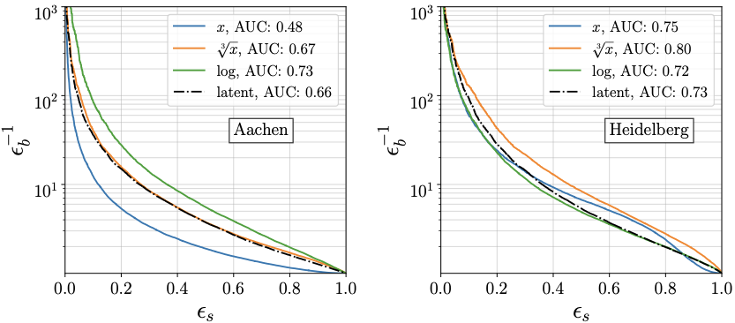

**Figure 1.** ROC curves for one of the anomaly detection algorithms detailed in Ref [3] for two different sets of new physics models, using density based tagging in physics and latent space. The density in physics space is affected by reweighting while the density in latent space is not [5].

# **References**

[1] ATLAS Collaboration, *Search for new phenomena in two-body invariant mass distributions using unsupervised machine learning for anomaly detection at 13 TeV with the ATLAS detector.* [arXiv:2307.01612](https://arxiv.org/abs/2307.01612) [hep-ex].

[2] G. Kasieczka, T. Plehn *et al., The Machine Learning Landscape of Top Taggers.* [SciPost Phys. 7, 014 (2019)](https://doi.org/10.21468/SciPostPhys.7.1.014). [arXiv:1902.09914](https://arxiv.org/abs/1902.09914) [hep-ph].

[3] ATLAS Collaboration, *Constituent-Based Top-Quark Tagging with the ATLAS Detector.*

[ATL-PHYS-PUB-2022-039](https://atlas.web.cern.ch/Atlas/GROUPS/PHYSICS/PUBNOTES/ATL-PHYS-PUB-2022-039/).

[4] Google Colab: <https://colab.research.google.com/?utm_source=scs-index>

[5] T. Buss *et al., What’s anomalous in LHC jets?* [SciPost Phys. 15, 168 (2023)](https://scipost.org/10.21468/SciPostPhys.15.4.168). [arXiv:2202.00686](https://arxiv.org/abs/2202.00686)

[hep-ph].